DEPARTMENT OF INFORMATION TECHNOLOGYGY

Final Year Project - Interim Report
Network Monitoring System
IT114104-2B Iu Hiu Pan
IT114104-2B Tam Siu Kei
IT114104-2B Lau Chun Yin
IT114104-2A Siu Man Ho

Contents

Introduction 2
Program Background 2
What is SNMP? 2
Requirement Specification 4
Methodology 5
Use Case Diagrams 1 6
Basic information of Use Case Diagram 1 7
Use Case Diagram 2 8
Basic information of Use Case 2 9
Fully Dressed Use Cases 10
Database Design 13
Data Dictionary 14
Sequence Diagrams 17
GUI Design 21
Test Plan 28
Difficulties encountered and the corresponding solutions 30
Expected upcoming progression 31
Conclusion 32
Reference 33

Introduction

Program Background
Nowadays, many company using internet to assist their business. For example, putting their services on internet to let people use their services anytime and anywhere. Therefore, network is a very important component, it is in charge of the communication within the company and the access from the outside of the company. If there are some network problem happened. For example, the server or router down because of it can't cope with the heavy workload. It will affect to normal function of the company and it may cause huge economic losses. Therefore, we need to know the information about the network component, determine the load of these devices and to plan for upgrades or changes. However, there are many servers and some router in the same network, it is very hard for the administrator to check all these devices physically.

Therefore, we are now developing a Network Monitoring System (NMS) using a protocol called SNMP, which is a build-in services of devices. This system will be installed in a Management PC to collect the information of devices centrally. To help the administrator to keep in touch with these devices.

What is SNMP?
Simple Network Management Protocol (SNMP) is an "Internet-standard protocol for managing devices on IP networks". Devices that typically support SNMP include routers, switches, servers, workstations, printers, modem racks and more. SNMP is used mostly in network management systems to monitor network-attached devices for conditions that warrant administrative attention. SNMP is a component of the Internet Protocol Suite as defined by the Internet Engineering Task Force (IETF). It consists of a set of standards for network management, including an application layer protocol, a database schema, and a set of data objects.

MIB
MIB is a collection of information used for managing devices in the network. Network devices have a database called ‘MIB’ with the set of ‘objects’. These object stores valuable information like memory status, hardware status, etc. within the network device.

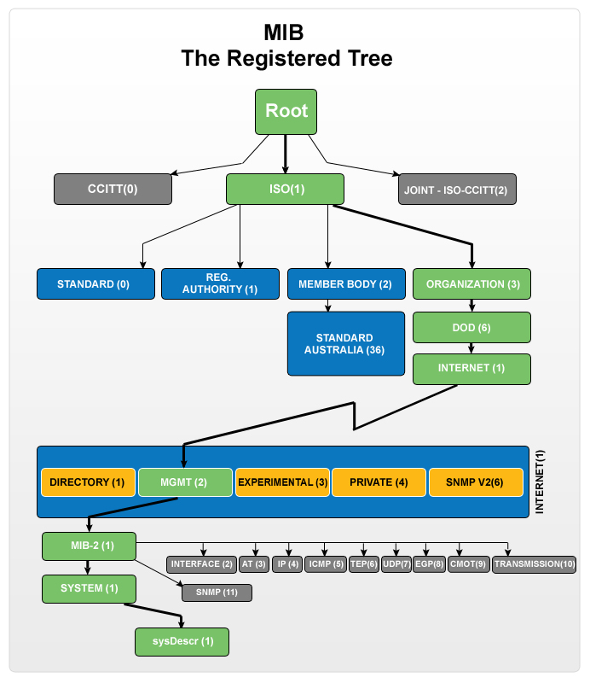

OID
As you can see, every directory have a number, link up the numbers, we can get a OID or Object Identifier, for example, .1.3.6.1.2.1.1.1 which represent sysDescr in the MIB.

Agent
Agent is a program that build-in the device, after it received a request, it will collect the data in MIB with the OID and response it to the sender.

How it works?
For example, if you want to get the system name of your device, you can send a request to the device with the OID 1.3.6.1.2.1.1.5(sysName), after the agent received the request, it will use the OID to locate the target object. After locating, it retrieves that information from the MIB table and reports to you.

Requirement Specification

Devices status capturing (Manually)
This is the main feature of the program, we can get status form different device such as server, router or switch with the IP address.

Devices status capturing (Automatically)
The program will get the status from device every X minutes automatically. User can define the X.

Graphic User Interface
Create a clearly user interface for user, the GUI will represent the current status that we captured with graphics. To let the user understand those status easily.

Status Statistics
Get status with specific period of time, and generate a line chart to represent those statuses.

Record History
Get all the records of the device and output it into a text file.

Report Generating
When the program finish capturing, the status of device will save to DBMS, the user can output the current result to a word file from records.

Email Alert
The system will send a email to alert user when there are some device approaching the limit or some extreme changes.

DBMS for storage the status
Every time the program capture status from devices, it will save the device status to DBMS for future use.

Methodology

JAVA SE
Java SE can provide us to develop and deploy Java applications on desktop and servers.

SNMP4J
SNMP4J is an enterprise class free open source and state-of-the-art SNMP implementation for Java.

JFreeChart
JFreeChart is a free 100% Java chart library that makes it easy for developers to display professional quality charts in their applications.

JDBC
JDBC is a free library provided by Oracle. It use to connect MySQL server with the
java Program.

Docx4j
docx4j is an open source (ASLv2) Java library for creating and manipulating Microsoft Open XML (Word docx, PowerPoint pptx, and Excel xlsx) files.

Net-Snmp ( for Linux , agent software)
Net-SNMP is a suite of applications used to implement SNMP v1, SNMP v2c and SNMP v3 using both IPv4 and IPv6.

Linux CentOS7
Windows 7
These two OS is use to provide a testing environment.

Use Case Diagrams 1
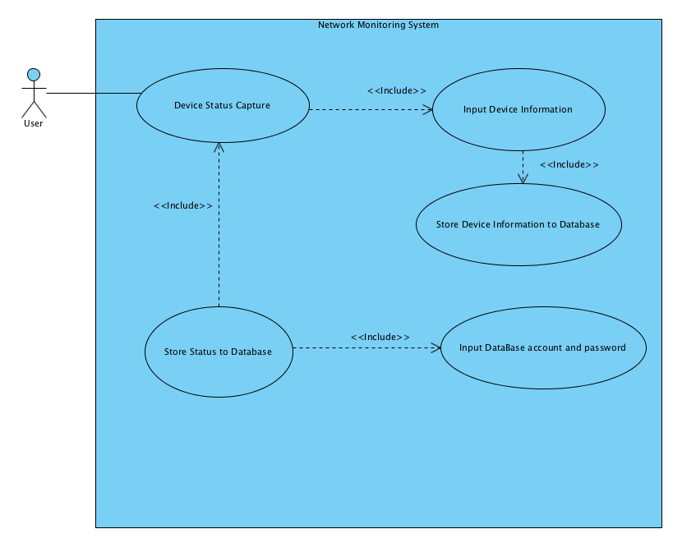

Basic information of Use Case Diagram 1
User
Use Cases: Device Status Capture

Device Status Capture
Actors: User
Include: Device Status Capture, Input Device Information
Include by: Store Status to Database, Device Status Capture

Input Database account and password
Include by: Store Status to Database

Input Device Information
Like IP address
Include: Input Device Information,Store Device Information to Database
Include by: Device Status Capture, Input Device Information

Store Device Information to Database
Include by: Input Device Information

Store Status to Database
Include: Input Database account and password, Device Status Capture

Use Case Diagram 2
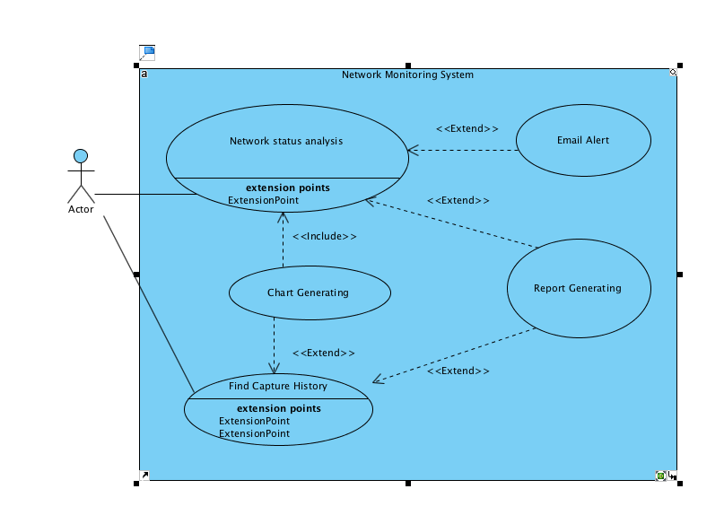

Basic information of Use Case 2
User
Use Cases: Find Capture History, Network status analysis

Chart Generating
Extend from: Find Capture History

Email Alert
Extend from: Network status analysis

Find Capture History
Actors: User
Extend: Chart Generating, Report Generating

Network status analysis
Actors: User
Extend: Email Alert, Report Generating

Report Generating
Extend from: Find Capture History, Network status analysis

Fully Dressed Use Cases
Case 1 : Device Status Capture
Primary Actor: | User
Stakeholders and Interests: | User: User can capture the device status on the local network ,store data to database.
Preconditions | - MySQL had installed.  - SNMP service had activated
Main Success Scenario: | 1. User can press “new” to new device  2. User can capture the device information  3. Capture status will store into database  4. Capture status will show on GUI
Extensions: | - After click “new” button  - User needs to input IP address and community.  - User needs to input database account and password.  - After capture the device information  - The capture information will show in the GUI.  - The information writes into database.
Errors | - The IP address input dialog is blank  - System prompts “The IP is blank” to user that needs to enter the IP.  - The community input dialog is blank  - System prompts “The Community Is blank” to user that needs to enter the community.
Frequency of Occurrence: | Frequently happen

Case 2 : Chart Generating
Primary Actor: | User
Stakeholders and Interests: | User: User can get status with specific period of time.
Preconditions | - MySQL had installed.  - SNMP service had activated  - User already create a target
Main Success Scenario: | 1. User can press ”Find History” button  2. User choose the target type of status  3. User choose the date  4. User click “Get” button  5. User can see a line chart pop out
Extensions: | - After click “Find History” button  User needs to choose the target type of status and date  - Program get the target records from database  - Show the records with a pie chart on the GUI.
Errors | - The user didn’t choose the target type  - System prompts “Please choose the type” to user that needs to choose the type of record  - The user didn’t choose the target date  - System prompts “Please choose the date” to user that needs to choose the target date.
Frequency of Occurrence: | Happen when user want to get records statistics

Case 3 : Find Capture History
Primary Actor: | User
Stakeholders and Interests: | User: User can get all record form database
Preconditions | - MySQL had installed.  - SNMP service had activated  - User already create a target
Main Success Scenario: | 1. User can press ”All record” button  2. User choose the path  3. User click “Get” button
Extensions: | - After click “All records” button  User need to choose the target path  - Program get all the records from database  - Program generates a text file with all records to the target path.
Errors | - The user didn’t choose the path.  - System prompts “Please choose the path” to user that needs to choose the path.
Frequency of Occurrence: | Happen when user want to get all records

Database Design
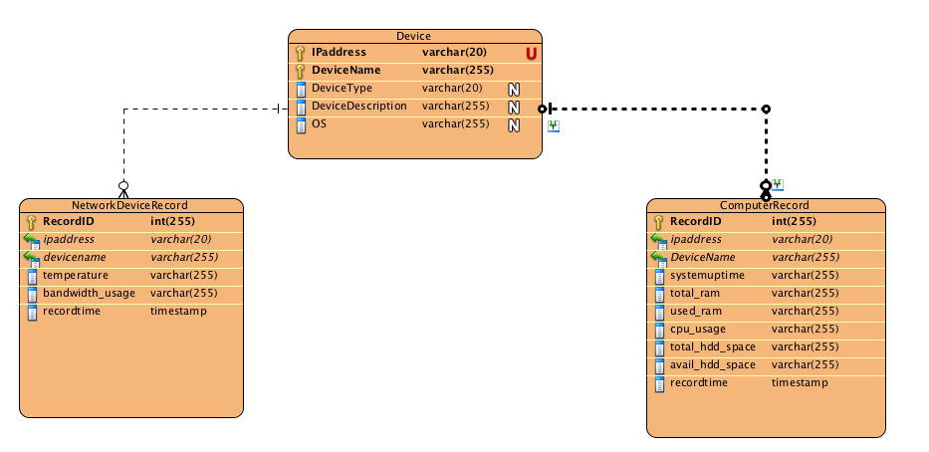

Data Dictionary

Entity Name |  | Entity Description
 | Column Name | Column Description | Data Type | Length | Primary Key | Nullable | Unique
NetworkDeviceRecord
 | RecordID | Auto Generated | int | 255 | true | false | false
 | ipaddress | Reference to device.ipaddress | varchar | 20 | false | false | false
 | devicename | Reference to device.devicename | varchar | 255 | false | false | false
 | temperature | The temperature of switch | varchar | 255 | false | false | false
 | bandwidth_usage | The number of the switch's bandwidth using | varchar | 255 | false | false | false
 | recordtime | it will be generate when the record add to the table. | timestamp | 0 | false | false | false
ComputerRecord
 | RecordID | Auto generated | int | 255 | true | false | false
 | ipaddress | reference to device.ipaddress | varchar | 20 | false | false | false
 | DeviceName | reference to device.devicename | varchar | 255 | false | false | false
 | systemuptime | The time of the computer turned on. | varchar | 255 | false | false | false
 | total_ram | The total number of RAM | varchar | 255 | false | false | false
 | used_ram | The number of how many ram does the device used. | varchar | 255 | false | false | false
 | cpu_usage | The number of the power of cpu | varchar | 255 | false | false | false
 | total_hdd_space | The total number of harddisk storge | varchar | 255 | false | false | false
 | avail_hdd_space | The number of current space of the harddisk | varchar | 255 | false | false | false
 | recordtime | it will be generate when the record add to the table. | timestamp | 0 | false | false | false
Device
 | IPaddress | IP address of the device | varchar | 20 | true | false | true
 | DeviceName | Name of Device | varchar | 255 | true | false | false
 | DeviceType |  | varchar | 20 | false | true | false
 | DeviceDescription |  | varchar | 255 | false | true | false
 | OS |  | varchar | 255 | false | true | false

Sequence Diagrams
Device Status Capture
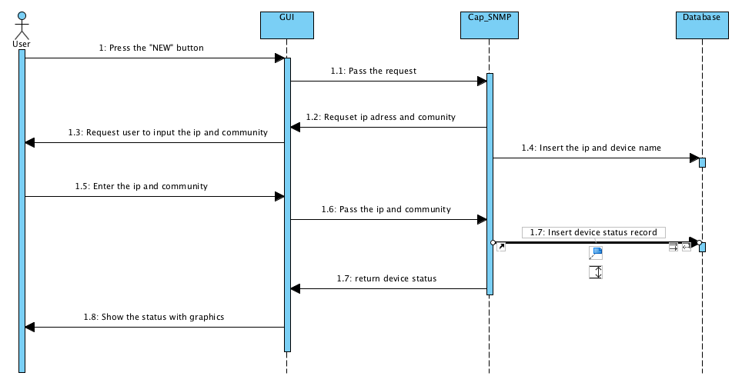

Chart Generating
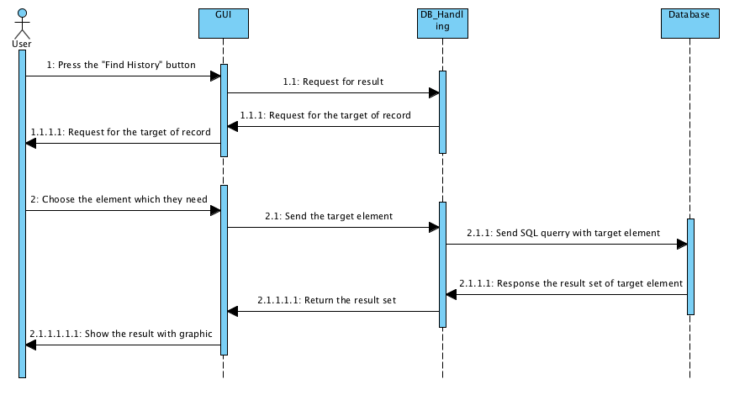

Find Capture History

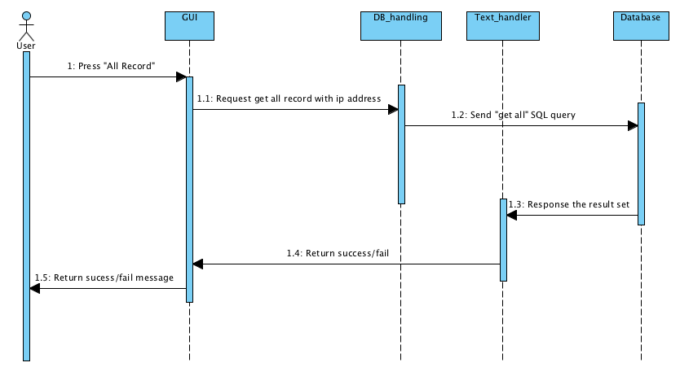

Report Generating

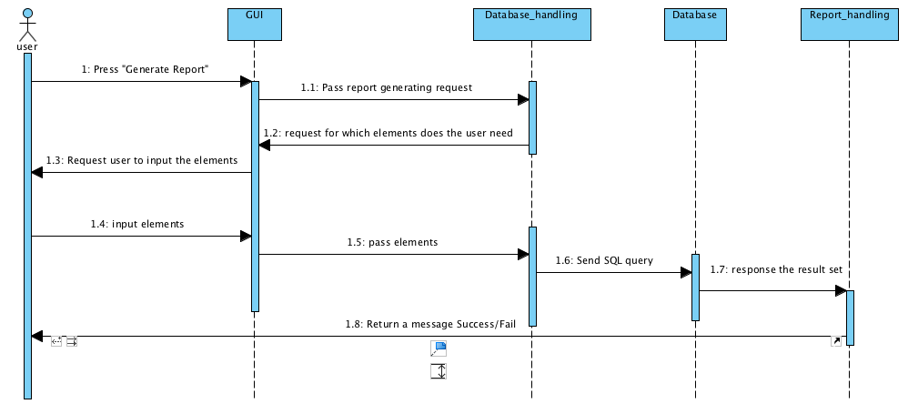

GUI Design
Menu
Display the status

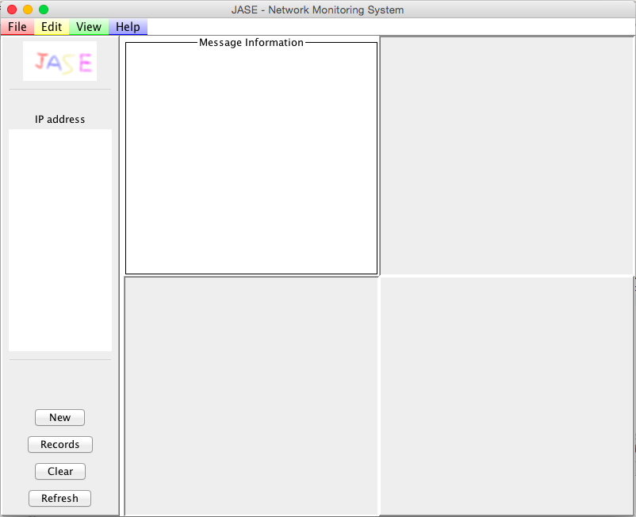
Device list
Create a target
Get all records
1
2
3
4
Clear all current status
Recapture the status

For the Display Box, we divided it into 4 parts.
1: Display the “message information”
2: Display the “Hard disk Usage”
3: Display the “Ram Usage”
4: Display the “CPU Usage”

Main Page – Menu Bar
Same function with the “New button”
We will explain later when introduce the “New Button”.

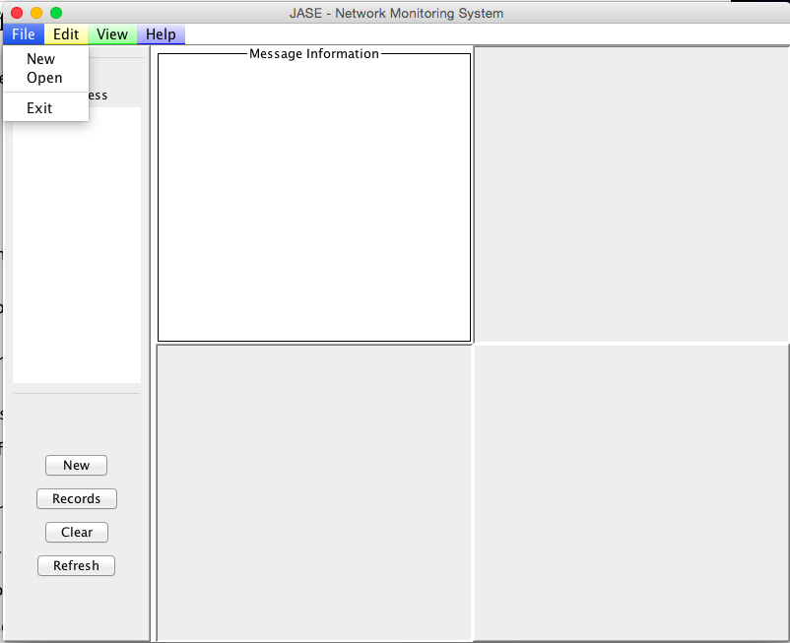
Close the program

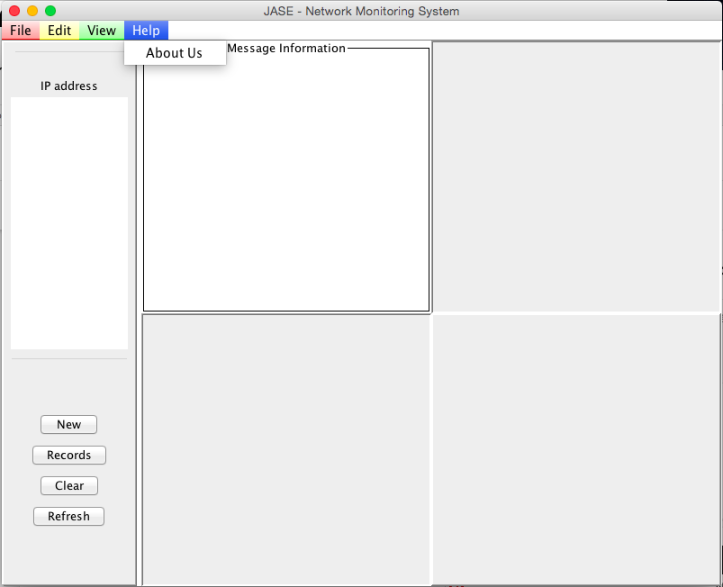
Press “About Us” when you need contact us.
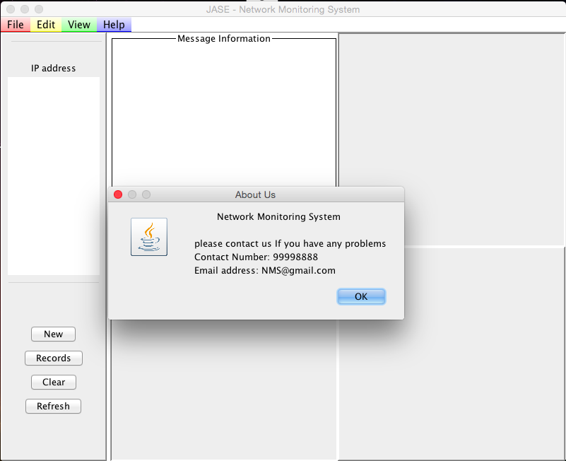
After user press “About us”, it will show a message dialog.
PS: Only File (New and Exit) and Help (About US) have set functions. (Current version)
Main Page – New button:

When user click the button, it will show two input message dialog for user to enter information.
- Input the target IP address.
- Input the community

For examples: if the user want to capture status from sever. User can input the IP address: “172.16.114.136” and the community “public” such as following:

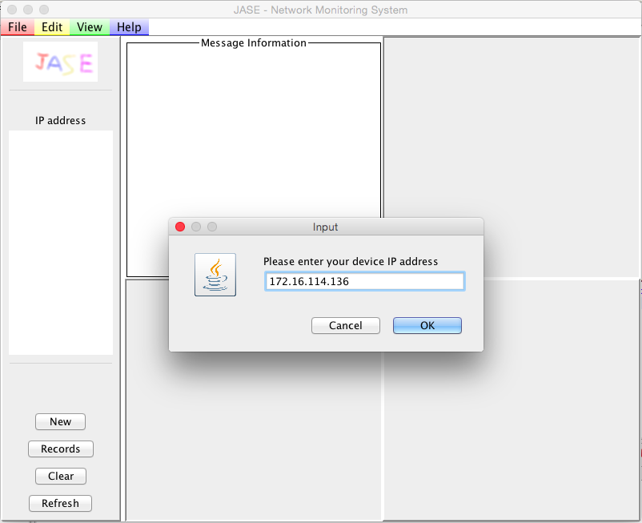

Input: 172.16.114.136 then click “OK”. After it user will see the next input message dialog

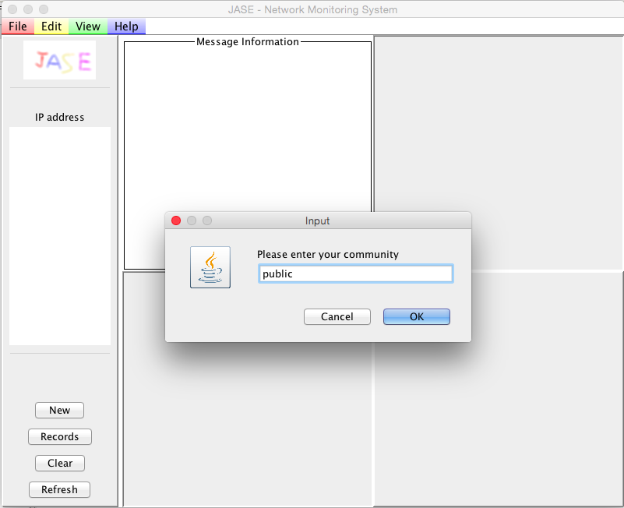

Input “public” and then click “ok”

Result
IP address box
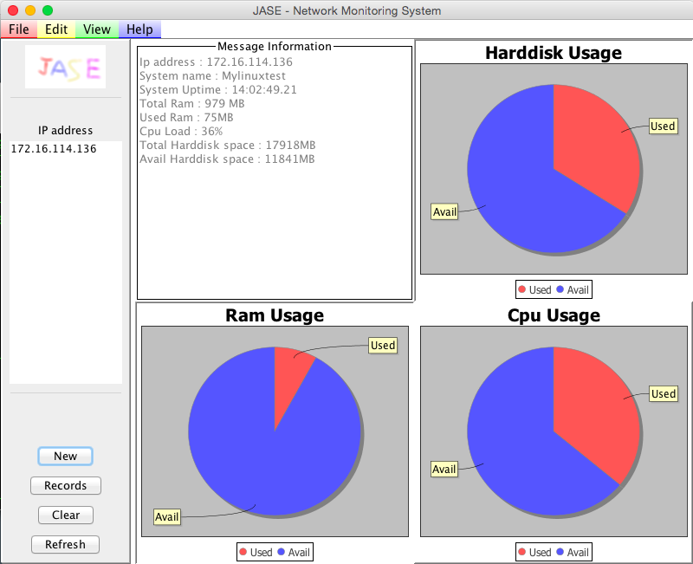

You will see the IP address (172.16.114.136) on the IP address Box and the related information regarding the IP address will be show on the right side. It contains the message information, hard disk usage, ram usage and CPU usage.

Test Plan

Test ID | Test Description | Test Procedure | Expected Result | Pass/Fail
A01 | User can get status from device successfully | 1.Click “New” button  2.Enter the target IP and Community  3.Get the status | The Status will show on the GUI | Pass
A02 | About Us button function | 1.User click the “About Us” button in the menu bar | Pop up a Message Dialog and show the Contact information | Pass
A03 | Exit button function | 1.User click the “Exit” button in the menu bar  2.Click “Yes” in the confirm dialog. | The program will be cancelled | Pass
A04 | User can clear the current status that showed on the GUI | 1.User click the “Clear” button.  2.Click “Yes” in the confirm dialog | The status showed on the GUI will be cleared. | Pass
A05 | User can refresh the status of device | 1. User click the ”Refresh” button. | The status showed on the GUI will be changed | Pass
A06 | User can get status with specific period of time | 1.User click the “ Find History” button  2. Choose the time and the target status  3. Click “Get” button | A line chart with the status record will pop out. | Pass

A07 | User can get all the record from a single device | 1.User click the  ”Records” button  2.Choose the path  3.Click “OK” | A text file with all records of the target device will generate to the path. | Pass
A08 | User leave the input dialog blank when they creating a target. | 1.User click the “New” button  2.Leave the input dialog blank  3.Click “OK” | A message dialog will pop out and request user to input the IP address again | Pass
A09 | User click the “Records” button without current target. | 1.User click the “Records” without target. | A message dialog pop out to inform the user that he need to create a target first | Pass
A10 | User click the “Find History” button without current target. | 1.User click the “Find History” without target. | A message dialog pop out to inform the user that he need to create a target first | Pass
A11 | User leave the target and date blank when they using the “Find History” function | 1.User click the “Find History”.  2. Leave the target and date blank  3.Click “Get” button | A message dialog pop out to inform the user that he need to choose the target and time | Pass

Difficulties encountered and the corresponding solutions

Different Device Different OID

In the network, there are many different type of network devices and different model. For different type of device or model, they have their own OID for getting information. It is very hard to handle all these network devices.

To solve the problem, we need to create different classes for different type of device or narrowing the types of network device. We can target on the most common model.

Record in database

Every time we get status from the device, it will save the record into the database. So, we need to determine which field will be the primary key. Initially, we decided to use IP address for the primary key, but there are many records with the same IP address. Therefore, we need a field which is unique.

Therefore, we created a field called record id, every time we insert a record into the database, the database will generate a number and put it into the record id field.

Combination of program

In order to make the project more smoothly and to expedite progress, we have divided the job in different part. However, when we combine different parts of the programs. We found that there are many error and bugs.

Wherefore, we need to find a place to combine the program together and keep communicate with others. Also, we need spend some time to discuss and study each other program. So, we can understand the flow of the whole program.

Expected upcoming progression

Add more capturing elements
At present, our program only provide capturing status from Linux server, we will make more types of devices available in our program. For example, switch and router. Also, we would like capture more types of status form the device.

Output Word report
At the present stage, our program can generate text file only, we will strengthen the function of report generating. So, the program can generate a word report with form and chart to represent records neatly.

Auto Capturing
In the future, we would like to add a timer on the main program to run the program every 5 minutes automatically. Therefore, the administrator can get more data for statistical purposes.

Email Alert
In order to let the administrator can receive messages at any time when some problem happened on the server or router, we would like add a email alert functions to alert the administrator when there are some server or router approaching the limit.

Conclusion
To conclude, our software aims to provide a clearly GUI for the administrator to get the status of device from the network easily. Therefore, the administrator can manage those status centrally. For example, user can use it to capture the current status of the device and retrieve the records anytime. Also, they can choose the data represent method, may be a report or a simple line chart. With these functions, the user can evaluate the status of the devices more easily.

In the future, there are some aspects of the system need to be strengthened.
For the administrator, the current available device and status capturing is not enough, they need more status to evaluate the devices. We have to strengthen the functions of status capturing to make it more diversified. So, administrator can get more information about the device.

Besides, the user can’t always keep checking the monitoring system. We need to add a alert function to alert the user when there are some server or router approaching the limit. Therefore, the user can take necessary countermeasures.

This is current progress and some aspects need to be strengthened in the program.

Reference
-SNMP4J Official Website
Retrieved from http://www.snmp4j.org/

-JFreeChart Official Website
Retrieved from http://www.jfree.org/jfreechart/

-Doc4j Official Website
Retrieved from http://www.docx4java.org/trac/docx4j

-oracle website about JDBC
Retrieved from http://www.oracle.com/technetwork/java/javase/jdbc/index.html

- [系統開發生命週期]Use Case Diagram概述
Retrieved from http://www.dotblogs.com.tw..../use-case-diagram.aspx

-Functional requirement on Wikipedia
Retrieved from http://en.wikipedia.org/wiki/Functional_requirement

- {UML2.0} Sequence Diagram 簡單範例與說明
Retrieved from http://www.kenming.idv.tw..._e_eo

O'Reilly & Associates. (2001). JTree and TreeModel (Java Foundation Classes).
Retrieved from http://docstore.mik.ua/orelly/java-ent/jfc/ch03_19.htm

Oracle / affiliates. (1995). How to Write a Mouse Listener
Retrieved from http://docs.oracle.com/....events/mouselistener.html

Tutorialspoint. (2014). Java Simple GUI - Programming Examples
Retrieved from http://www.tutorialspoint.com/javaexamples/gui_piechart.htm

Tutorialspoint. (2012). SWING Event Handling.
Retrieved from http://www.tutorialspoint.com/swing/swing_event_handling.htm

Ouali Idrissi Med Amine. (2013, January 6). JAVA Swing Tutorial 5
Retrieved from https://www.youtube.com/watch?v=92H0AN6egFI

